Teaching Notes - Table saw (INTRO)

*Note: Try to use all new blades of similar diameter to avoid issues with riving knife adjustment.
- Classroom:
  - Review TSaw Parts video https://youtu.be/TbVKPXAWxjM (Also on BB)
  - Mark Adams video series: https://www.finewoodworking.com/2013/03/26/episode-1-tablesaw-safety
  - Optional: View the video on how a SawStop works: https://youtu.be/yMmInsxTcww
  - View TSaw “Adjustments” playlist of videos on BB (click “play all”)
- Lab Activity:
  - Select 4 teams (count off 1, 2, 3, 4), Each team put a different blade on a saw blade (Rip, ATB, T/C; & Combination blade - refer to info sheet 2)
    - Team / Saw#
      - #1 Triple Chip
      - #2 Rip
      - #3 Combination
      - #4 Crosscut
  - At machine: Review Excaliber guard adjustment
  - Discuss LOTO & Cartridge issues @ machine;
    - Demo blade install,
    - Riving Knife removal/install;
    - throat plate install & leveling screws
    - Show QR codes for videos (on shaper cabinet?)
  - S’s install blades, discuss blade hook angle

- Watch “Ripping” (3:42) Crosscutting (3:42) and “Rabbetting” (2:30)
- At machine: Discuss: Push Sticks
- Throat Plates (incl. Zero-clearance) & Adjustments
- Adjusting Backer boards at Miter gauges; Calibrating miter gauges
- Calibrating fence & digital stop;
- 4:12 rule (hand distance : minimum part length)
- Review never “Cut past a square” rule
- Discuss Machine Codes
- Demo ripping
- Discuss miter gauges, cross-cut sleds
  - When can you use 2 fences together?

- Task: (See last page – print 1 copy/group)
- S’s complete task in groups
- Review samples and compare qualities of cut
- Show eye/tooth extraction animation video: https://youtu.be/Xu9tdfsuwC4

Final Comments:
- A humorous look at safety (1:06): http://youtu.be/_ZuWcqBEzpo
- Show exercise & drawing of in flat file
- Make test cuts!
- Kickbacks – video (4:57): https://youtu.be/u7sRrC2Jpp4
- Narrow Stock ripping - Summarize with Video: https://youtu.be/-oajYsw1dOQ
  - Use of zero clearance throat plate
  - Use of a stop block (Left of Blade)
  - Use of sacrificial push stick
- Housekeeping
  - Blow off when done
  - Don’t leave stock laying around on machine
  - Review table saw safety rules & checklist
- Review exercise criteria

Instructions for students:
-Rip a piece to 4”
- Square 1 end, Crosscut to 16”
- Put a 3/8”x3/8” rabbet on it
-Cut a groove ¼” deep down the center of your stock, the width of the blade
-Crosscut a ½” sample from the end of your stock and write your group # on it
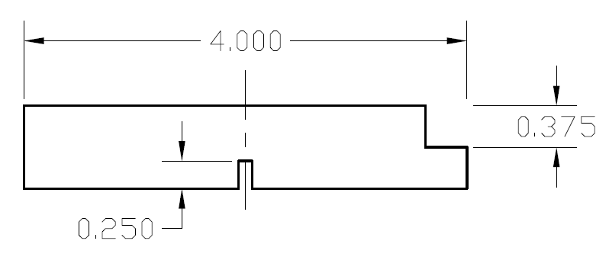

Instructions for students:
-Rip a piece to 4”
- Square 1 end, Crosscut to 16”
- Put a 3/8”x3/8” rabbet on it
-Cut a groove ¼” deep down the center of your stock, the width of the blade
-Crosscut a ½” sample from the end of your stock and write your group # on it

