Skill Activity 1

PARTS AND ADJUSTMENTS OF AN OSCILLATING SPINDLE SANDER

Completed | Procedure
 | 1. Use the labeled diagram or manual to help you locate these parts of the machine: switch, spindle (with taper socket), table tilt lock, table tilt handwheel, table inserts, sanding sleeve mandrels, tilt scale.
 | 2. Remove the mandrel that is in the spindle. Select a different mandrel from the rack. Make sure the taper shank is clean and free from nicks and dents. Install the mandrel by pressing it into the taper socket firmly. DO NOT DRIVE THE MANDREL IN WITH A HAMMER OR MALLET!
 | 3. Unlock the tilt lock and tilt the table to 22 ½ as shown on the tilt scale. Return the table to 0 and lock. Check it with a try square. Note: Watch the mandrel clearance carefully, and change the table insert if the mandrel is rubbing at any point.
 | 4. Start the machine and observe the action of the spindle. Stop the machine.

SPINDLE SANDER

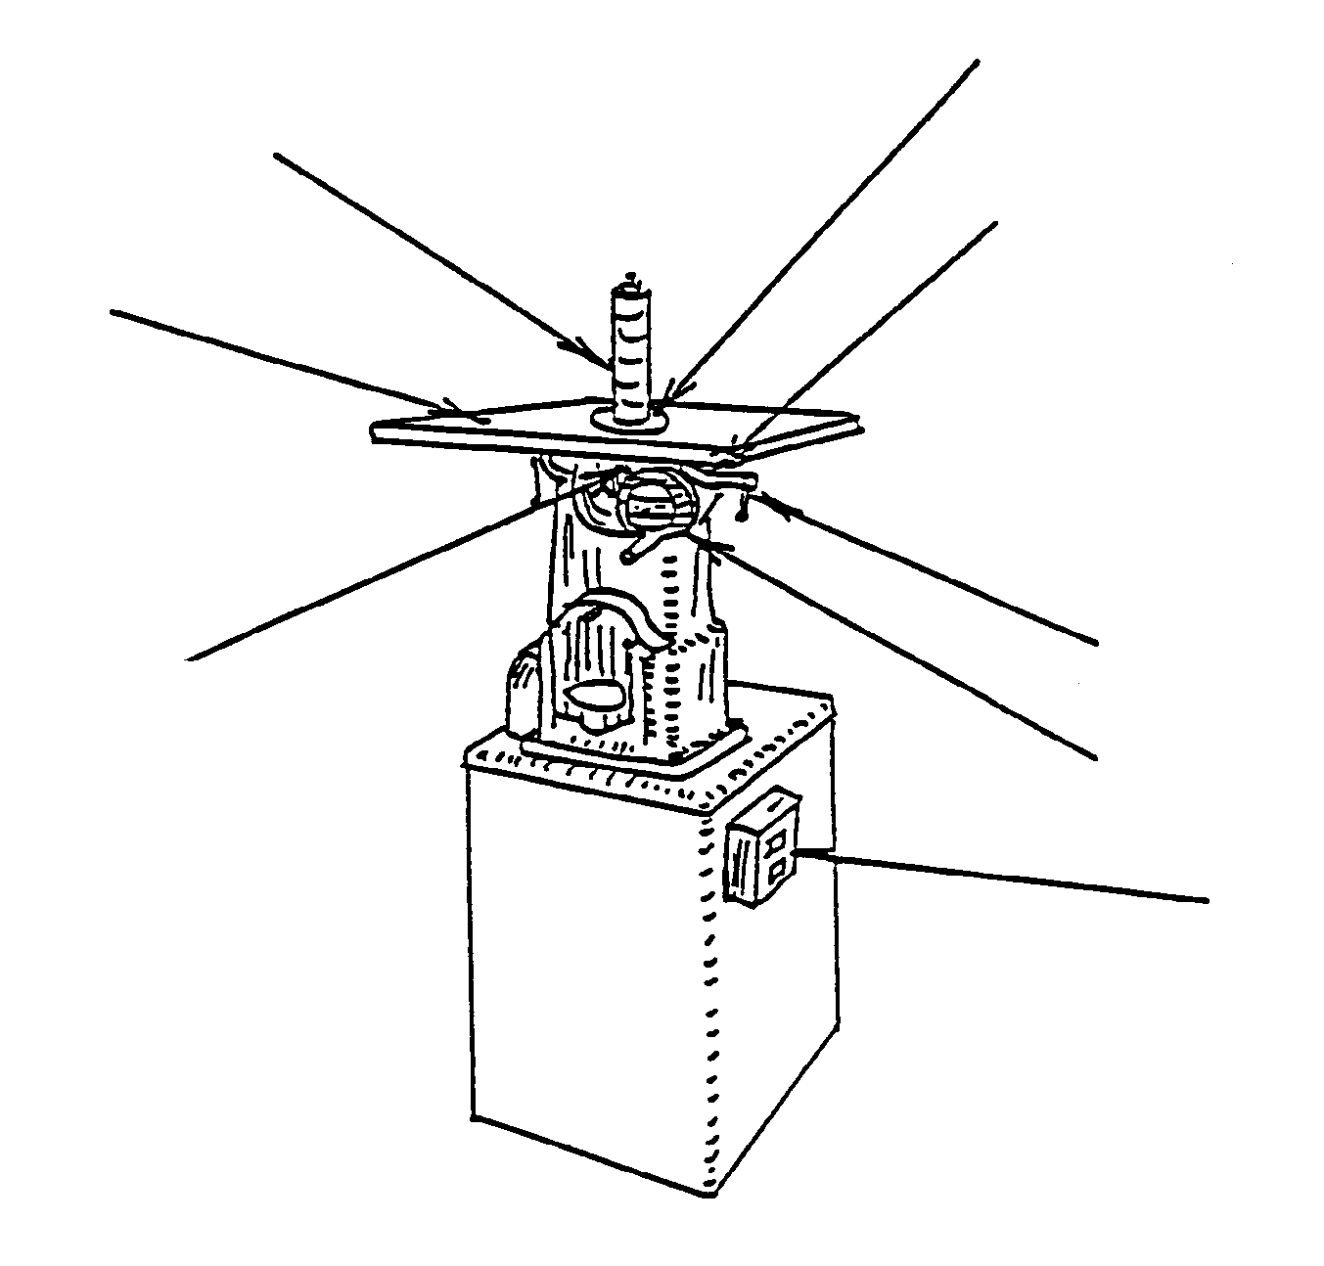
TILT SCALE

