Thickness Planer Demonstration Checklist:

Name___________________________________ Date____/____/____

Observer: ___________________________

With your instructor or an approved proxy, demonstrate on a Planer:

- Describe machine hazards & demonstrate lock-out/tag-out procedures
- On/off switch
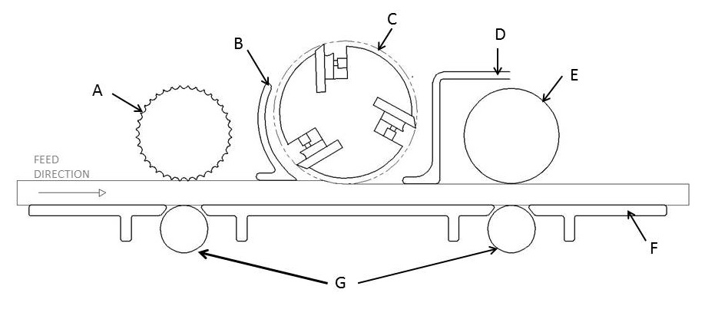
- Identify the parts in the diagram: → →
- Thickness adjustment
- Speed control
  - Oliver
  - Format 4
  - DeWalt
- Bed roller adjustment (Oliver only)
- What determines the minimum length of stock which can be fed?
- Thickness scale calibration (check current reading).
- What is the typical amount of material to be removed on a single pass?
- Demonstration proper grain orientation using samples
- Location of and proper use of a backer board
- Dry run of planing (proper hand and standing position, proper depth setting relative to an actual sample)

Student’s Signature: _________________________

(By signing this document you are indicating that you have reviewed the Safety Rules and understand the proper operation, maintenance and safety procedures for this machine).

Instructor’s Approval: _________________________ Date____/____/____

