Information Sheet 3

IDENTIFY THE PARTS OF AN EDGE SANDER

To take full advantage of a sander, you need to know the location and purpose of their parts.

Belt sander

Study Figure 1 to identify the main parts of a belt sander, and then read the descriptions that follow.
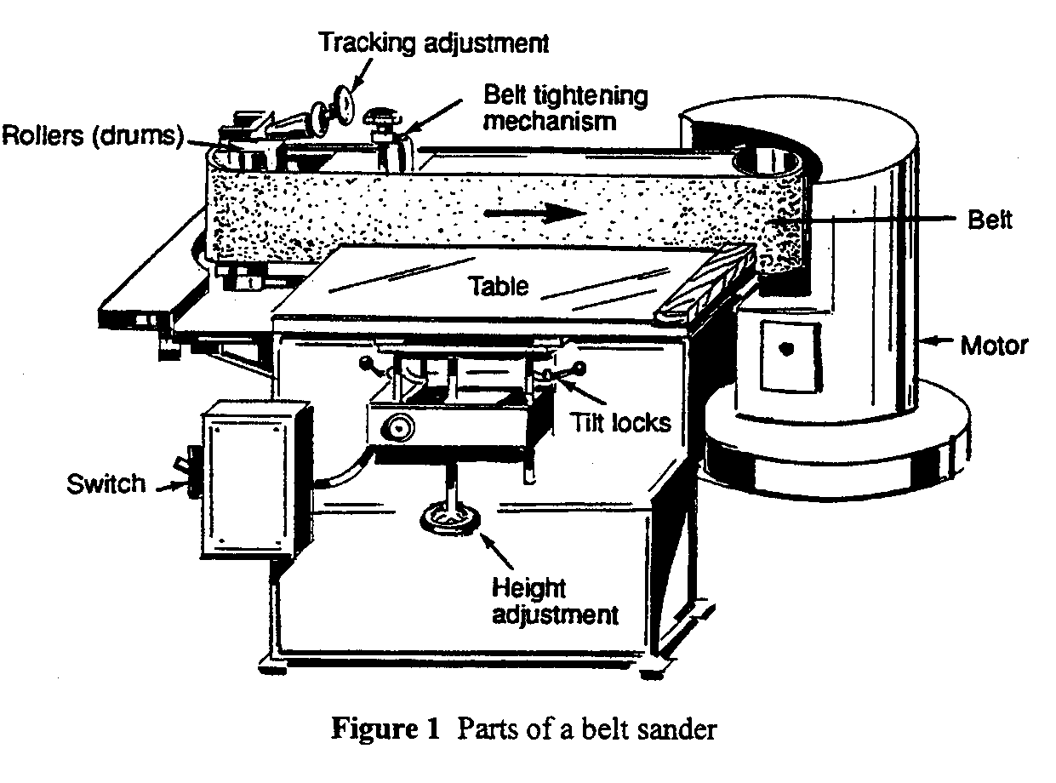

Motor

The motor turns one of the rollers at the end of the belt. Power is transferred to the roller by a V-belt.

Motor switch

This switch turns the power on and off.

Rollers

At the two ends of the sanding belt is a roller (also called a drum) on which the sanding belt rides. One roller provides power to the belt; the other keeps the belt tracking properly. Both should be slightly crowned at the centre to keep the belt tracking.

Abrasive belt

The abrasive belt contains the abrasive that removes wood during a sanding operation. The belt is stretched tight on the two end rollers and rides across a flat surface called the platen.

Platen

The platen is just behind the belt and is not shown on the diagram. It is a smooth metal plate which holds the sanding belt against the work and thus ensures a flat, sanded surface. If the sanding belt were simply stretched between two rollers, it would deflect when your work pressed against the belt. As a result, your work would acquire a convex curve.

Tracking adjustment

The idler roller (the roller that is not under power) has a tracking adjustment which tilts the roller slightly one way or the other. This tilting action allows the belt to ride in the middle of the rollers and thus track correctly.

Table

A table is often supplied with a sanding machine. It is adjustable and can be tilted toward the belt and/or away from it. It is used to support work when an accurate angle must be maintained during sanding.

Stop Fence

The stop is positioned across the table, near the end of the platen. It supports the stock to keep it in place during sanding. The stop fence can be rotated for angled stock.

Belt tightening mechanism

Some belt sanders have a spring-loaded roller which is used to apply tension to the belt. A lever retracts the roller to allow for belt changes. When tension is desired, the lever is released. Other sanders have a belt tension knob, which applies tension to the belt as it is tightened.

Tilt mechanism, scale and pointer

The table tilts on a trunnions under the table and is equipped with a tilt scale and pointer for reading the angle at which the table is tilted.

Tilt lock

When changing the tilt of the table, the locking mechanism must be released. When the table is at the desired angle, lock the mechanism to keep the table at its set angle.

Height adjustment

This hand wheel raises and lowers the table in order to take advantage of the entire belt’s surface.

Information Sheet 3

IDENTIFY THE PARTS OF A DISK SANDER

Disk sander

Study the location of disk sander parts in Figure 2, then read the descriptions that follow.
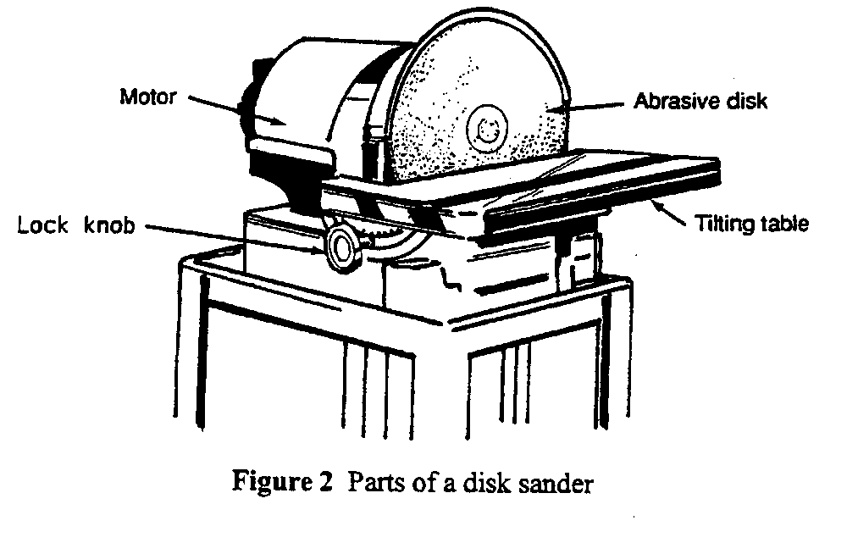

Motor

The motor provides the spinning action of the disk sander.

Abrasive disk

The abrasive disk is glued to the metal disk. It provides a flat, accurate, abrasive surface for sanding.

Tilting table

The tilting table on the disk sander can be tilted from 0° (square to the face of the disk) to 45° (sloping downward and away from the disk).

Lock knob

The tilting table is held in the desired position by the lock knob. This knob is usually near the tilt scale and pointer, which indicates that the table in its proper position.

