Information Sheet 2

OPERATIONS WITH A BAND SAW

Note: Your instructor will demonstrate the operations performed with a band saw. The descriptions that follow are simply guidelines to each operation. You must attend a demonstration and feel comfortable about the safety procedures before operating any powered equipment in the woodwork shop.

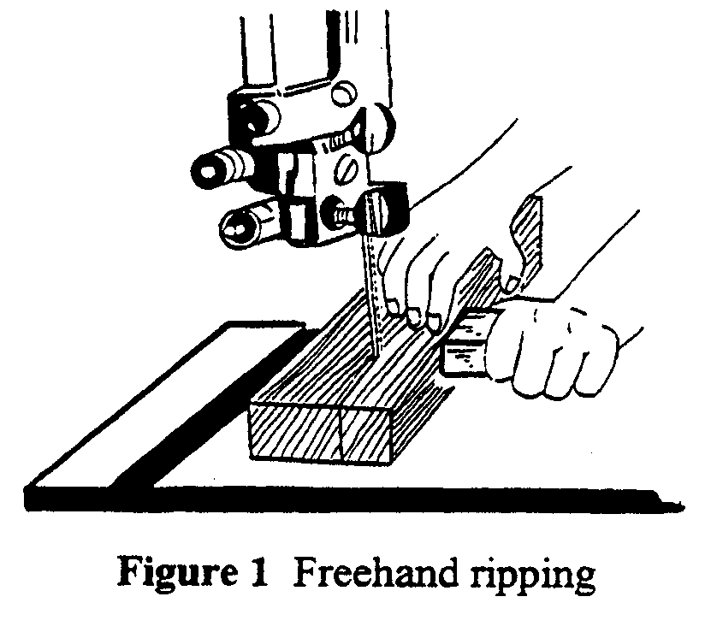
Ripping

Ripping on the band saw is often done freehand. When ripping freehand, you will get better results by resting one hand beside the stock, just in front of the blade, and using your thumb as a “mini fence” to guide the stock through the blade (Figure 1). Freehand ripping is normally done only if one or two pieces of stock need ripping, or if there are straight lines in the pattern.

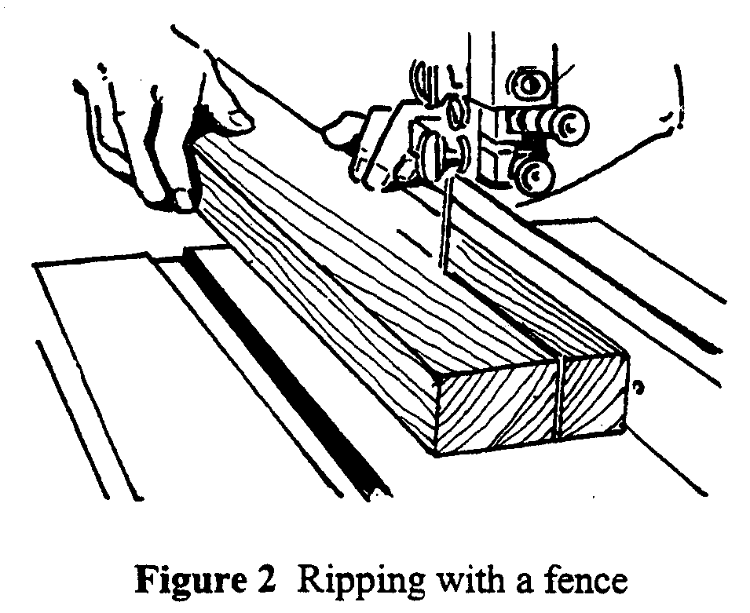

If several pieces need ripping on the band saw, you should use the fence illustrated in
Figure 2.

Band saw blades cut straight only when the teeth on both sides of the blade are equally sharp. If you notice that the blade does not cut straight, the teeth on one side of the blade are not as sharp as those on the other side. The blade will tend to wander towards the sharp side.

This wandering is called drift or “lead”. If you rip freehand, you can compensate for it by aligning the cut line with the path of the blade (Figure 3).

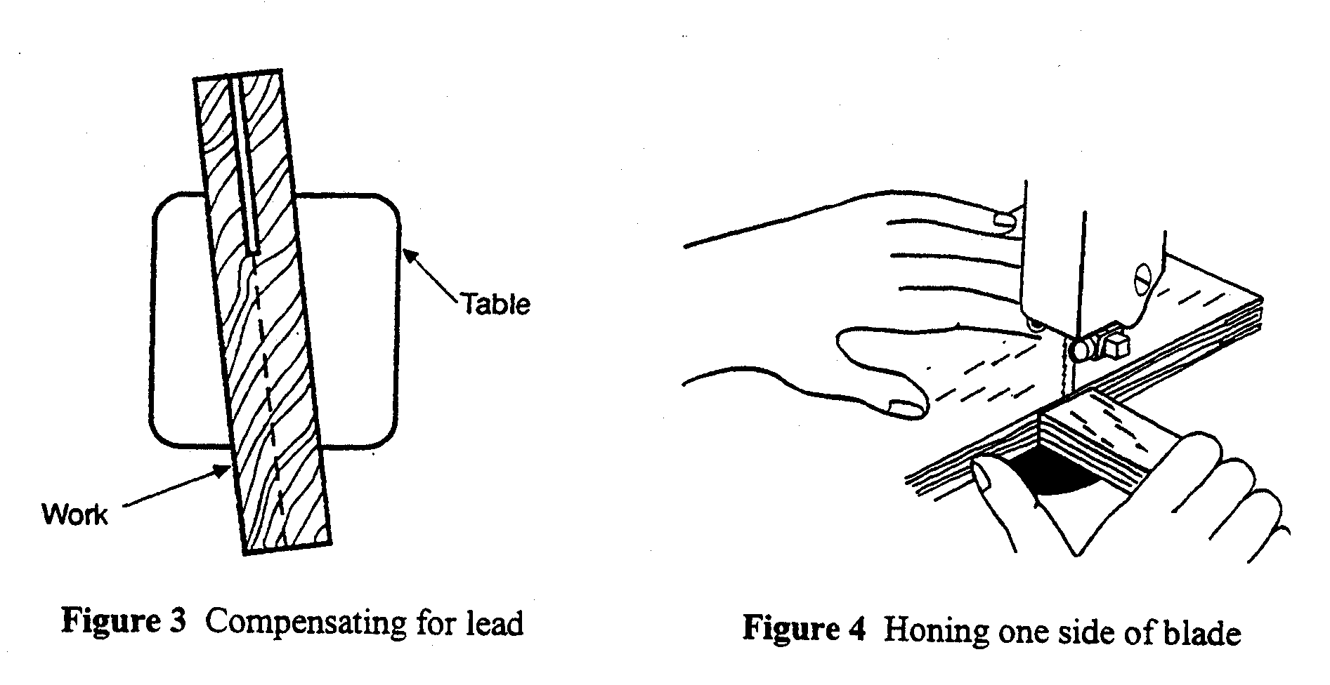
If you use the type of fence illustrated in Figure 2, you will not be able to compensate for the drift demonstrated in Figure 3. You will be required to change the blade or hone the sharp side of the blade as shown in Figure 4. Honing should be used only as a last resort since, to eliminate drift, you will make the sharp side of the blade dull.

One ripping operation well suited for the band saw is resawing wide boards into two or more thin pieces (Figure 5). Since the grain of the lumber will often cause the blade to wander during resawing, a pivot block, instead of a straight fence, is used to guide the material. The pivot block keeps the board parallel to and at a constant distance from the blade, yet it allows you to steer the board to compensate for drift.

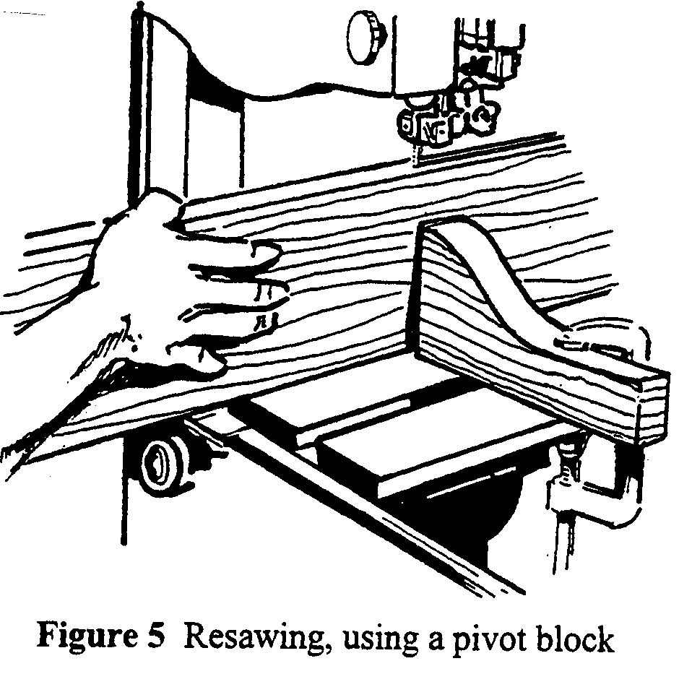

Ripping dowels

Dowels and other rounded stock tend to rotate during a cut, causing the sides to be spiraled. To prevent this, you need a vertical splitter bar behind the blade. You can clamp a short V-block with a nail driven into the centre of the V as shown in Figure 6. The nail will prevent the dowel from turning as the cut is made. It must, however, be vertical, for if it is angled, the stock will spiral throughout the length of the cut.

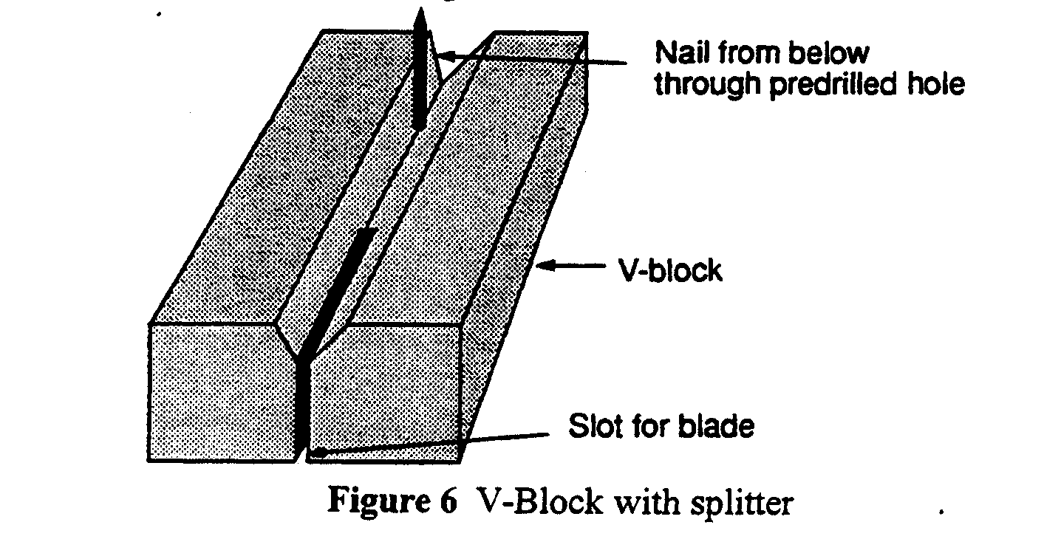

Alternatively, short sections of dowels can be ripped without spiraling if you clamp a square block to each side of the dowel so that the blocks rest on the table during the cut (Figure 7).

