Information Sheet 1

POWER MITER SAW SAFETY RULES

1. Follow all General Shop Safety Rules.

2. Be sure the miter adjustment is locked in position before starting the cut.

3. Hold the stock firmly against the fence when cutting.

4. Keep hands clear of the line of cut.

CUTTING BOWED MATERIAL
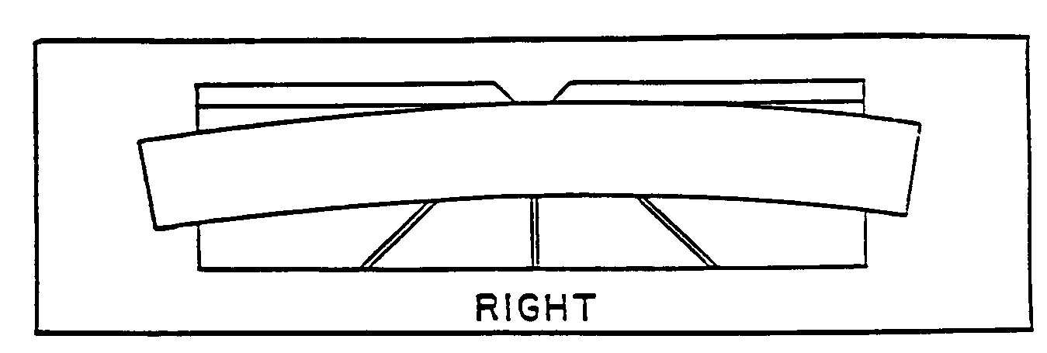
When cutting flat pieces, first check to see if the material is bowed. If it is, make sure the material is positioned on the table as pictured above.

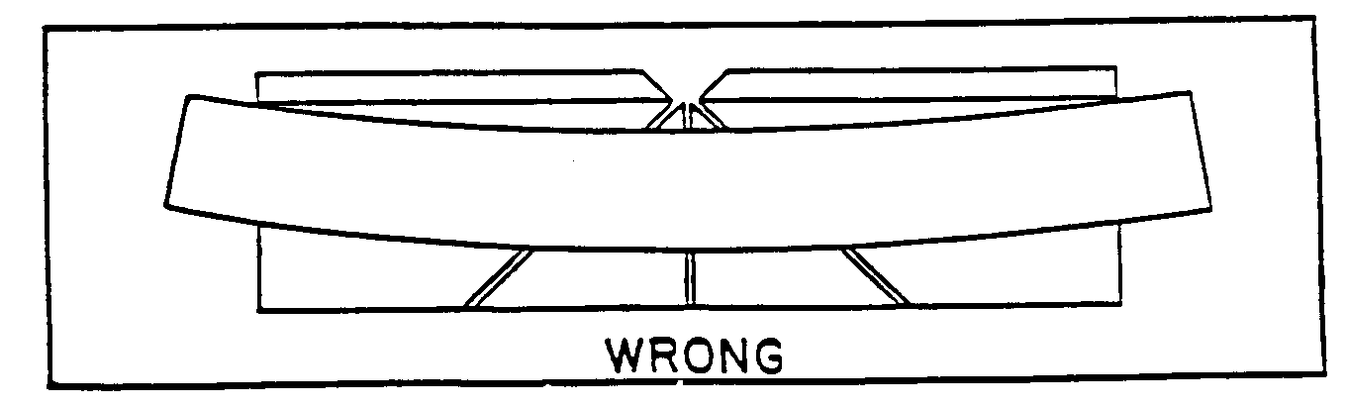
If the material is positioned the wrong way, as shown above, the material will pinch the blade near the completion of the cut.

