Information Sheet 3

IDENTIFY THE PARTS OF A DRILL PRESS

Study Figure 1 to locate the parts listed below. As you read about the function of each of the parts, refer back to Figure 1 to refresh your memory of its exact location.

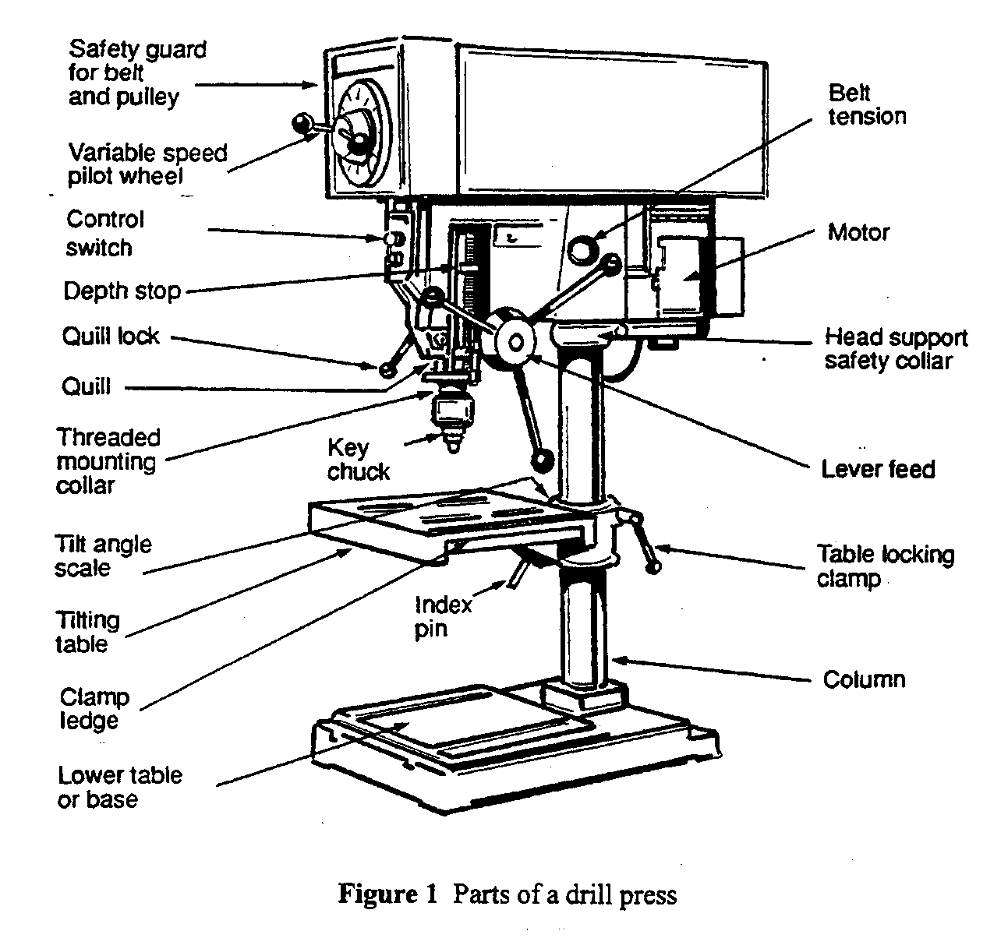
Control switch

The control switch turns the power to the motor on and off. The location varies from one model to the next but will be easy to reach in an emergency.

Quill

Inside the head of the drill press, there is a vertical sleeve known as the quill. The quill contains the rotating shaft to which the drill chuck and the drill bit are attached. The quill can be moved up and down during drilling operations. It is spring-loaded to help return it to its uppermost position.
Quill return-spring housing

The quill return-spring housing is usually located on the left side of the head, just at the back of the quill. It contains a wound spring which returns the quill to its uppermost position. The spring tension is adjusted by rotating the housing.

Quill clamp

There are occasions when the quill must be locked at a certain height. This is done by locking the quill clamp.

Depth stop and rod
When a drilled hole must be to an exact depth, the depth stop on the depth-stop rod is set and locked. This prevents the quill from being lowered past the desired depth and ensures that all holes are drilled to the same depth.

Feed lever

The feed lever rotates the pinion shaft.

Pinion shaft

The pinion shaft operates a rack-and pinion gear assembly, which moves the quill up and down during a drilling operation.

Spindle

The spindle is a rotating shaft which is housed inside the quill.

Geared chuck

The chuck, which is mounted on the bottom end of the spindle, holds the drill bit. It is available for bit shaft diameters of 6 mm, 9 mm and 12 mm, but most drill presses are also capable of holding a bit with a shaft diameter of 12 mm. The term, geared chuck, means that the chuck is tightened on the bit by a geared chuck key.

Table

To support work, the drill press is equipped with a flat table which can be raised or lowered to accommodate different stock thickness. Some drill presses have tables that can be tilted to allow you to drill work at an angle. The table has slots in it so that small pieces of work can be fastened to it. It also has flattened edges to permit clamping larger pieces. All tables have a hole in the centre to allow the drill bit to fully penetrate both the work and the table.

Table clamp
The table clamp holds the table to the column. It must be loosened when you want to raise or lower the table, and when the table is at the desired height, it must be tightened again to prevent further movement. When the clamp is loose, the table can also swing left or right. Always check that the table hole is aligned with the center of the bit before you tighten the clamp.

Table-tile scale and pointer

When you tilt the table, you can determine the angle at which you have tilted it by reading the tilt scale and pointer. When the table is level, or at 90° to the shaft of the drill bit, the scale should read 0°. The scale has readings from 0° to 90° to the left and right.

Index pin

To help set table at 0°, there is an index pin which locates the table at exactly 0°. You must remove the pin when you tilt the table.

Column

The column is the vertical shaft that supports the table and the head.

Base

The base supports the column. It should be fastened to the floor or to the workbench as any rocking at the base will be greatly exaggerated at the top of the column and could cause the unit to tip over.

Belt guard

A belt transfers power from the motor to the spindle. The belt is usually mounted on a pair of step pulleys or a variable speed pulley. A belt guard guards the entire belt and pulley assembly.

