Exercise 9.1

STATIONARY SANDERS (EDGE, DISK & SPINDLE)

(Refer to drawing on following page).
Completed | Procedure
- Review the Spindle, Edge and Disk Sander Safety Rules.
- Obtain the template and exercise stock. Trace the contour on the stock.
- Use the band saw to cut the entire contour to within 1/16” of the layout line. DO NOT CUT OVER THE LINE. Internal contours will need to be drilled and cut with a scroll or jig saw. Use of a Forstner bit is recommended.
- Use the Edge sander to sand the external contours & straight edges. Open the dust collector blast gate. Start the belt and oscillation motors.
- Using LIGHT PRESSURE, sand the straight edge and curved corners of the layout. (Do not tilt the piece. Check with a try square for even thickness and squareness with the side.)
- Use the Spindle Sander to sand any inside and concave contours. USE LIGHT PRESSURE! Excess sanding pressure will burn your work piece and cause your abrasives to load up. Be sure that you do not sand past your lines. Note: The table will need to be tilted for the under bevels.
- Use the Disk Sander to sand any external contours which cannot be done safely using the Edge Sander. Note: The table will need to be tilted for the under bevels.
- Be sure to leave machines clean when finished and close dust collector blast gates.

You have now completed the Stationary Sander Machine skill exercise.

EVALUATION

Submit your exercise piece for evaluation.

Exercise 9.1

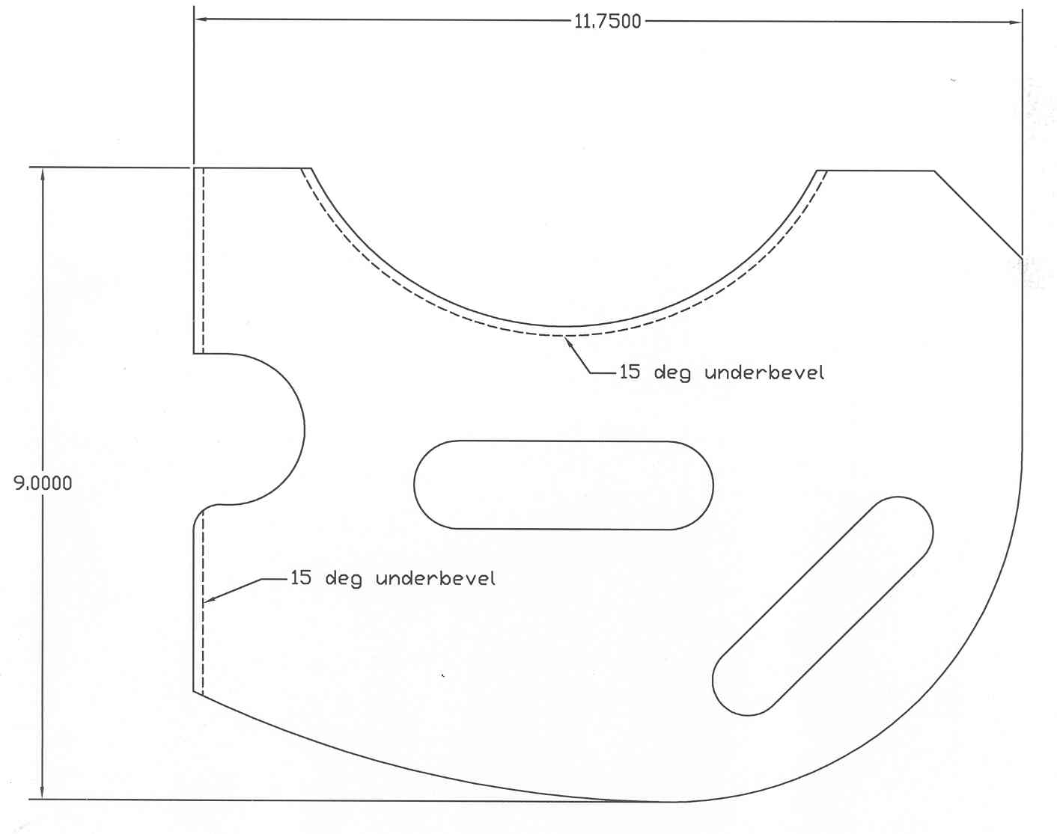
Small Arc
Large Arc
1.25” Slot
1” Slot

Scoring Guide: √ = Criteria met
O = Criteria not met

1" Slot | End Bevel | Large Arc | Small Arc | 1.25" Slot | Dimensional Accuracy +/- 1/32"  Quality = Fairness and consistency
Quality | Quality | Quality | Quality | Quality

Total: ______/10 (min. score 8/10)

Comments:

