Exercise 8.1

TABLE SAW OPERATIONS

You should use your exercise piece from 2.3. If you do not have this piece, start by ripping a new piece to 4”, crosscutting to 16”, and proceeding as explained below.
Completed | Procedure

Steps 6-8: Cutting the Tenon:
6. Layout one end of the work piece for a centered, 3/8 x 1¼" tenon, as shown.
7. Clamp a short board to the fence as a stop, and adjust the fence for the length of the tenon. Adjust the blade to the correct height and make the shoulder cuts.
8. There are two options for cutting the cheeks of the tenon. Whichever method you use, make sure there is a clean backer block to minimize tearout.
Single Pass Option: Set the dado blades and spacers to the correct height for the cheek cuts, and using the tenoning jig to hold the stock, make the cheek cuts. Ask the instructor to check your set-up.
Two Pass Option: Using the homemade tenoning jig and a single Flat Top Grind blade, adjust the fence to cut the outermost cheek from the jig. After the first pass, rotate the stock and make a second pass. The tenon will automatically be centered.
Note: credit will not be awarded for tenons cut flat with a dado blade.
9. Remove the blades and spacers and install the dado set with enough chippers to make a 5/8" cut. MAKE SURE THAT THE CHIPPERS ARE EVENLY SPACED, AND THAT THE TIPS FALL INTO THE LARGE GULLETS ON THE OUTER BLADES. Before you tighten the arbor nut, ask the instructor to check your set-up. Use the dado table insert for this operation.
10. Layout and cut the 5/8" wide dado, as shown, 1/4" deep, using the miter gage.
11. Remove the Dado set from the arbor. HANDLE BLADES AND DADO SET WITH CARE! Return dado head to cabinet.
12. Using a single, Flat Top blade, cut a groove down the center of the stock 1/4” deep, with the width being the thickness of the blade.
13. Tilt the blade to 22½ degrees and chamfer the end of the tenon, leaving 1/16” of end-grain material. Do not reduce the length of the piece. Consult the print in the classroom for clarification.
14. Set the miter gage to 45 degrees and miter the end opposite the tenon. Use a combination square to check the angle, and be sure not to reduce the length of the piece. Note the starting location if using stock without the rabbet.
15. Use a taper jig and the fence to cut a one inch per foot taper on the edge opposite the rabbet.

Evaluation: Submit your exercise to your instructor for review.
TABLE SAW SKILL EXERCISE 8.1

Note: Refer to drawing in classroom for better clarity on dimensions. Crosscut, Rip and Rabbet operations are shown here but were done as part of Ex. 2.3. If using new stock, you will need to rip to 4” and crosscut to 16”, but you do not need to re-do the rabbet <or> you can reuse Ex. 2.3.

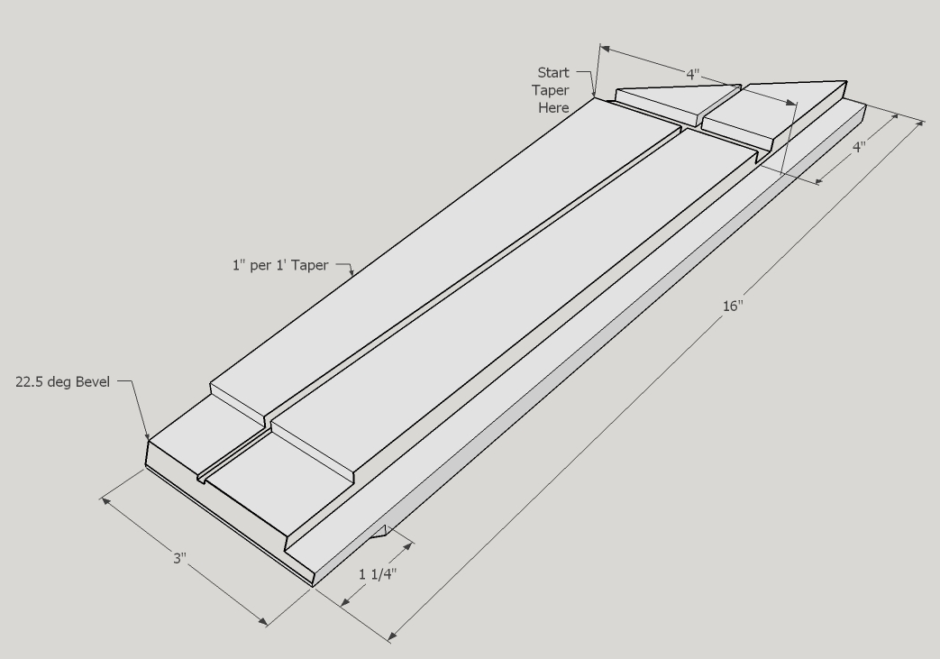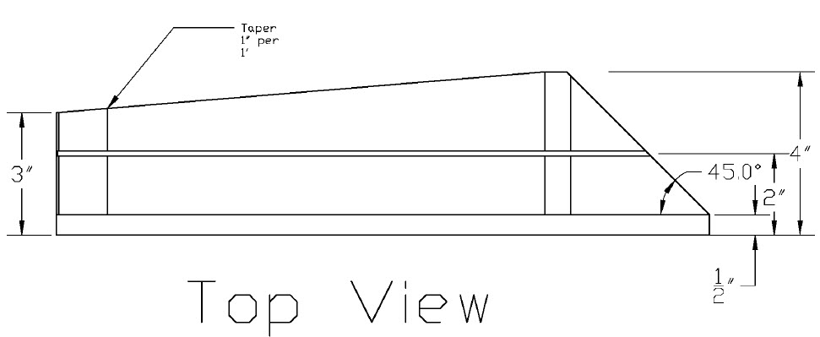
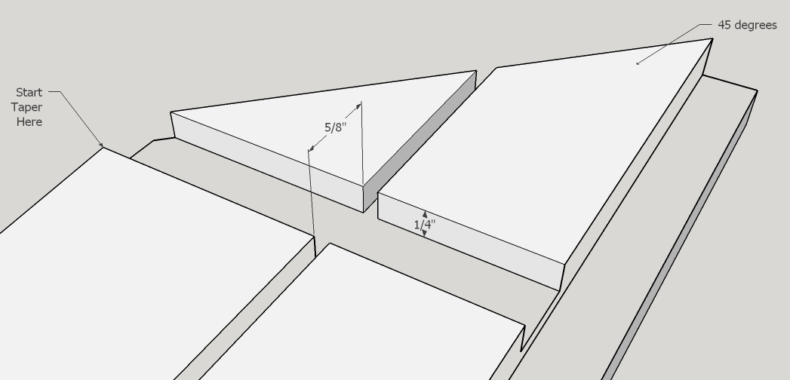

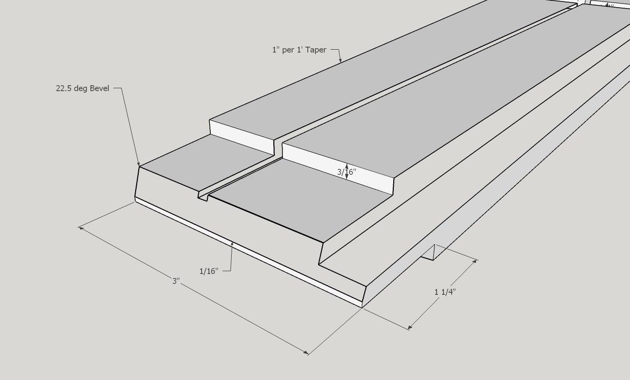

Grading Criteria (12 points): √ = Criteria met Each box (□) = ½ point U.N.O.
O = Criteria not met
Tenon | Dado | Groove | Taper | Miter | Chamfer
□ Thick (3/8") □ Length (1.25”) | □ Width (5/8") □ Depth (1/4") | □ Width (1/8") □ Depth (1/4") | □ Within ¼” of dado  □ (3") at end | □ Angle +/- .5 deg (1 pt) | □ Accuracy of flat (1/16") (1 point)
□ Quality  □ Location | □ Quality  □ Location | □ Quality  □ Location. | □ Quality  □ Location | □ Quality  □ Location | □ Quality  □ Location
Dimensional Accuracy +/- 1/32" Quality = minimal burning or tearout Loc. = Correct Location

***Bonus: 2 points if ALL operations are correctly completed and on the same piece of stock.

Total: ______/12 pts (min. score 9.5/12)

Comments:

