Exercise 4.2

DRILL PRESS

This exercise is designed to give you practice in accurate layout, as well as practice in using all of the tooling you have examined in the SKILL you develop, and your ABILITY to do the work to exact specifications.
Completed | Procedure
□ | 1. Obtain stock from the instructor, 3/4 x 4 x 8. Lay out the hole locations and mark them exactly as shown on the drawing. (Before doing any drilling, make sure you have a clean backing board insert for the drill press table to prevent tear-out.)
□ | 2. Insert the 1/2" brad point bit into the chuck. (Make sure the chuck is tightened securely, and the drill press speed is set properly).
□ | 3. Bore hole #1 to 1/2" deep. Bore hole #2 all the way through the stock.
□ | 4. Use a 1/4" twist drill to bore through the center of hole #1. Then drill holes #3 and #4, both as thru-holes.
□ | 5. Obtain a #14 flat head wood screw. Using a countersink and the depth stop as a guide, countersink hole #3 so that the screw will fit flush with the surface of the stock.
 | 6. Hole #5: Set the machine to its slowest setting. Install a 2.125” diameter Forstner bit in the chuck. Use scrap stock to check your set-up. When you are satisfied with the setting, clamp the exercise stock in place and bore a 3/8" deep hole. Leave the stock clamped in place for step #7.
□ | 7. With the stock clamped in place, remove the Forstner bit, and install a 1" Forstner or Multi-spur bit. (If you have to lower the table to change tooling, be careful not to move the hole center out of alignment.) Using hole #5 as the center, drill a 1 " diameter counter bore, 1/4" deep (This is shown as hole #6).
□ | 8. Install the 1" spade bit, clamp the stock, and bore hole #7, 3/8" deep.
□ | 9. Bore hole #8, 5/8” deep, using a 3/4" Forstner bit and centering the hole on the edge of the stock as shown. The stock must be clamped in place. Using the same 3/4" Forstner bit bore hole #9 to a depth of 9/16".
□ | 10. Use the 1/2" plug cutter to cut 2 plugs 1/2" deep, as shown on the drawing. The stock must be held tightly to a fence or clamped in place when cutting plugs to keep the stock from slipping and resulting in undersized plugs.
□ | 11. With a small screwdriver, break one of the plugs loose from the stock, and glue it in hole #1. After the glue sets up, pare the plug flush with the surface using a SHARP Paring chisel. You have now completed drill press skill exercise.  Evaluation: Submit your exercise piece to the instructor for review.

Exercise 4.2

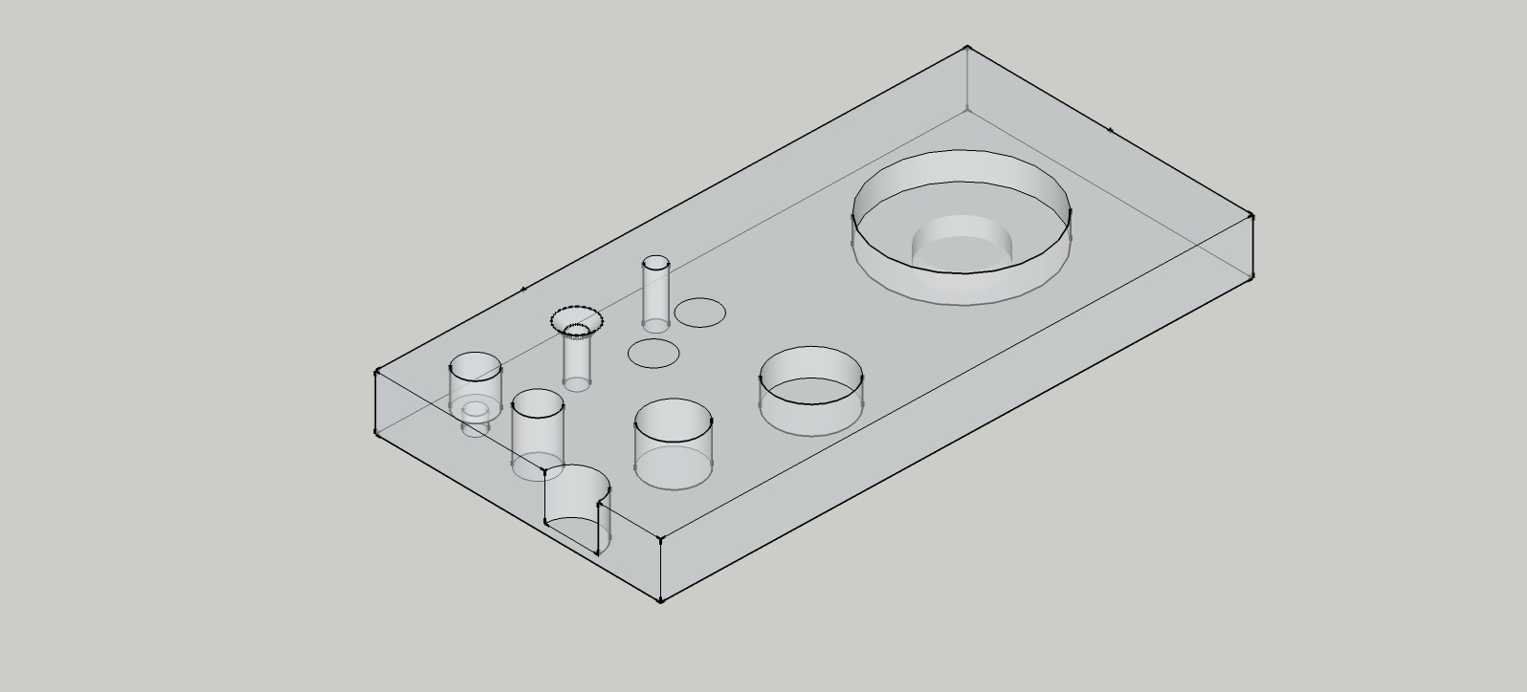

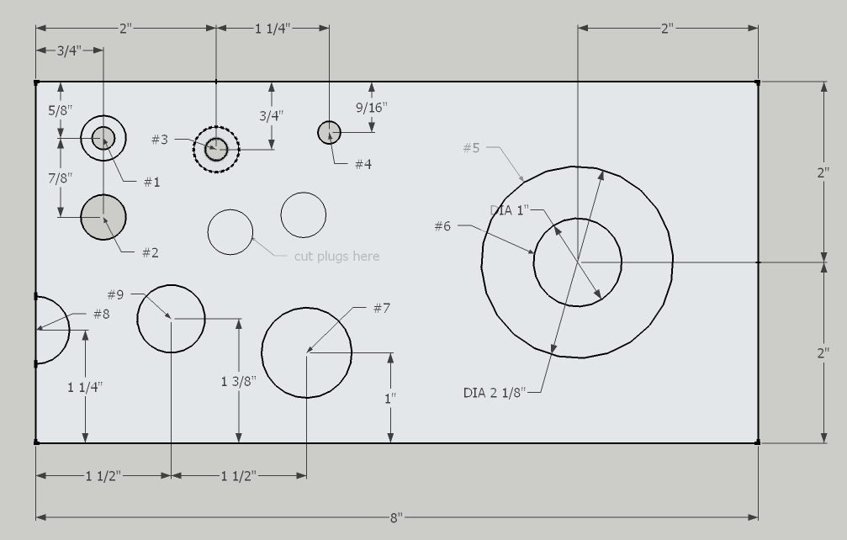

Hole 1:  ½” dia. X ½” deep | Hole 2:  ½” dia. thru-hole | Hole 3:  ¼” dia. thru-hole | Hole 4:  ¼” dia. thru-hole | Hole 5:  2-1/8” dia. x 3/8” deep | Dimensional Accuracy +/- 1/32" Quality = minimal burning or  tearout  Depth Accuracy +/- 1/16"
Location/ Quality | Location/ Quality | Location/ Quality | Location/ Quality | Location/ Quality
Hole 6:  1” dia. x ¼” deep | Hole 7:  1” di. X 3/8” deep | Hole 8:  ¾” dia. x 5/8” deep | Hole 9:  ¾” dia. x 9/16” deep | Quality of plugs drilled
Location/ Quality | Location/ Quality | Location/ Quality | Location/ Quality | Quality of plug fit & finish

Total: _______/10 (min. score 8/10)

Comments:

