Exercise 2.4

BAND SAW CUTTING

Obtain the contour pattern from the instructor. Align the straight edge of the pattern with the smooth edge of the piece. Trace the contour onto your stock with a pencil. You may want to obtain a piece of ½” solid stock to practice the cut. Relief cuts will be necessary to cut the inside radius. Cut as close to the line as possible, but do not overcut.

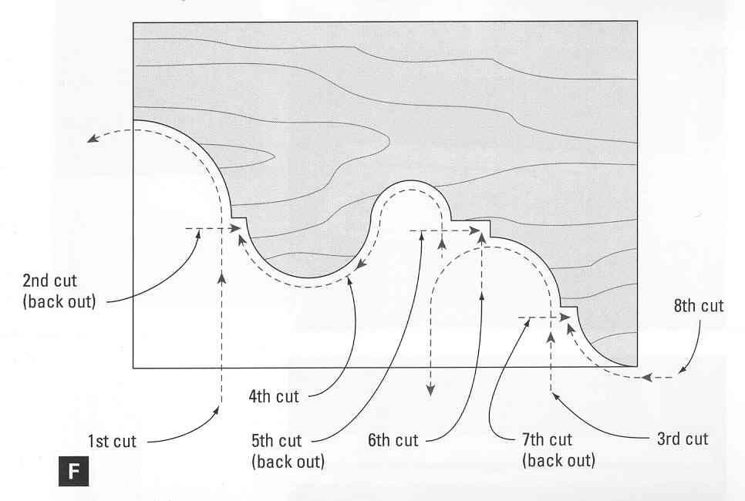
Scoring Guide

Overall Accuracy +1/16"/-0 (Points awarded for % correct over length)  (5 points) | Quality (5 points) = minimal burning or tearout and smoothness of cut

Total: _____/10 (min. score: 8/10)

Comments:

