Exercise 2.2
USING A POWER MITER SAW
Completed | Procedure
□ | 1. Obtain 3/4" x 2½" x 12" exercise stock. Follow the steps in order.
□ | 2. Square one end, then layout the length of the stock as shown on the drawing.
□ | 3. Set the saw at 45 degrees. Chamfer one end of the stock as shown in the drawing below (.375”)
□ | 4. Cut the angle on the stock as shown in the drawing below
□ | 5. Using a Compound Miter SAW, cut the compound angle as shown in the drawing.
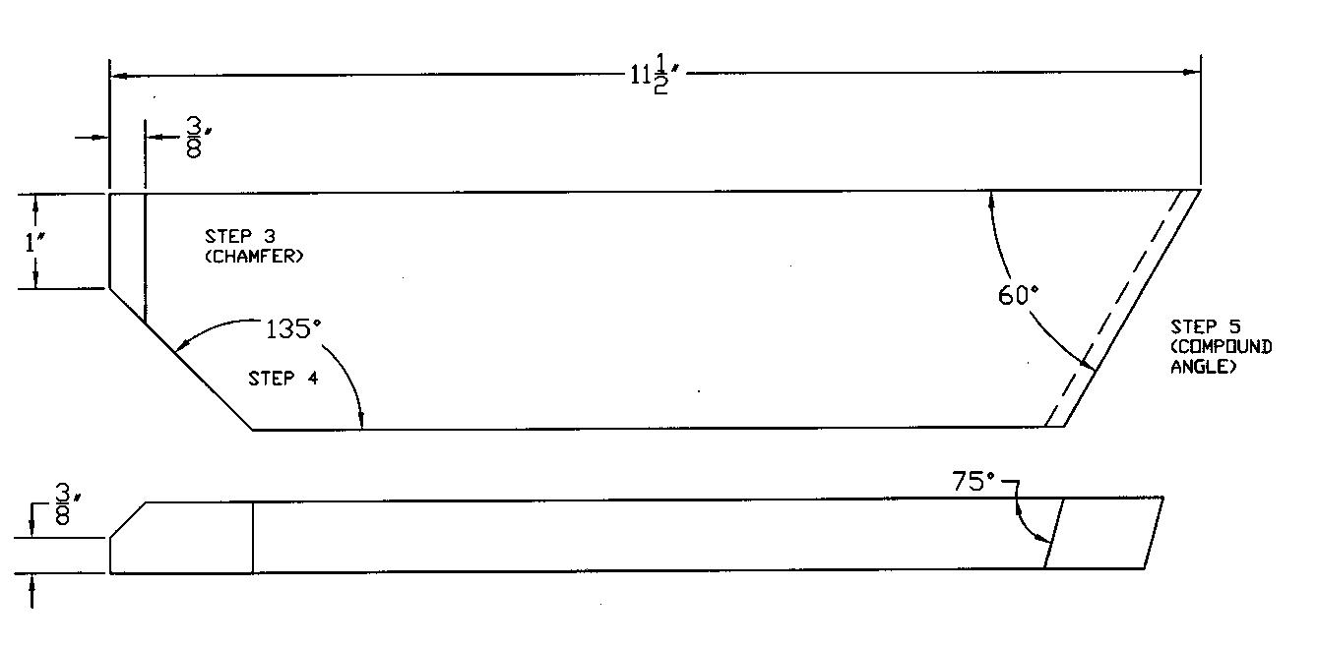

Scoring Guide: √ = Criteria met
O = Criteria not met
Length  Accuracy (1") | Length  Accuracy (11.5") | Angle  +/- 1 deg. | Bevel  +/- 1 deg. | Thickness Accuracy (.375") | Accuracy: +/- 1/32”
Quality | Quality | Quality | Quality | Quality | Quality = Minimal Tearout or Burn; Squareness

Total: ______/10 pts (min. score: 8/10)

Comments:

