EXERCISE 2.1 – PORTABLE POWER SAWS

Step by Step Instructions

Completed | Procedure
□ | 1. Review Portable Power Saw Safety Rules.
□ | 2. Obtain ½” x 12” x 12” Baltic Birch plywood stock. (Approx. size)
□ | 3. Layout the piece as shown on the drawing on the next page. Have your instructor check your layout before cutting.
□ | 4. Use a ½” spade bit to drill two holes in the corners of the center cutout as shown on the drawing. Use a saber saw to complete the cuts, squaring the corners. Complete the bottom notch as well.
□ | 5. Crosscut the piece to length using the Festool circular saw. Be careful to control the depth of cut and to properly support the saw track. Ask your instructor to check your setup before proceeding.
□ | 6. Rip the stock along the angled outside lines using the Festool circular saw.

Evaluation

Submit your piece to your instructor for review.

W1A - EXERCISE 2.1 – PORTABLE POWER SAWS Name: _____________________

Layout center cutout from the dimensions provided.
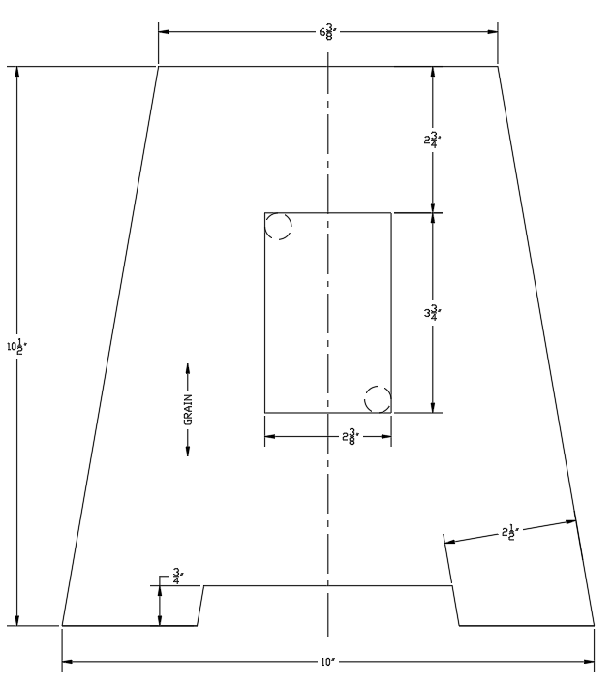
Evaluation:

- Overall Width at Bottom (10”)
- Overall width at top (6.375”) Dimensional Tolerances: +/- 1/16” U.N.O.
- Overall Height (10.5”)
- Accuracy of outlet cutout (+3/32”/-0)
- Product exhibits minimal tearout or burning
- Grain direction is correct

Minimum passing score: 5/6 Total Points: ______

Comments:

