Exercise 2.3A

TABLE SAW OPERATIONS (PAIRWORK)

Completed | Procedure
 | 1. Review the circular saw safety rules.
 | 2. Obtain 3/4 x 4-1/4” x 18” stock from the instructor. Study print on the last page carefully.
 | 3. Set the blade to project 1/4" to 1/2" above the thickness of the stock. Set the fence to rip the stock to 4" wide, as shown on the diagram. Check your set-up with a scrap piece. If it is correct, rip the exercise stock to 4". NOTE: Always use a scrap piece to check each set-up before performing the operation on your exercise stock.
 | 4. Using the miter gage, trim one end square. Trim the other end square, leaving the piece exactly 16" long. Always check miter gage for square.
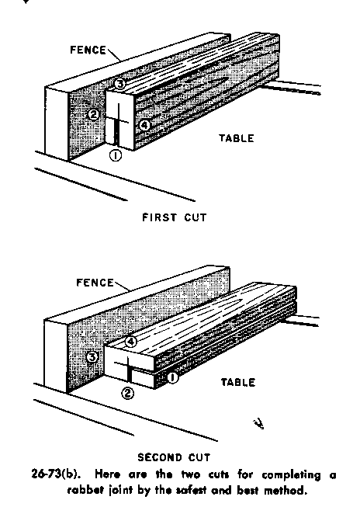 | - Following the procedure shown below, layout and cut a 1/2 x 3/8" rabbet along one edge of the stock, using a single blade and two passes. Be sure to keep the offal (waste) on the outside of the cut to avoid the potential of kickback.  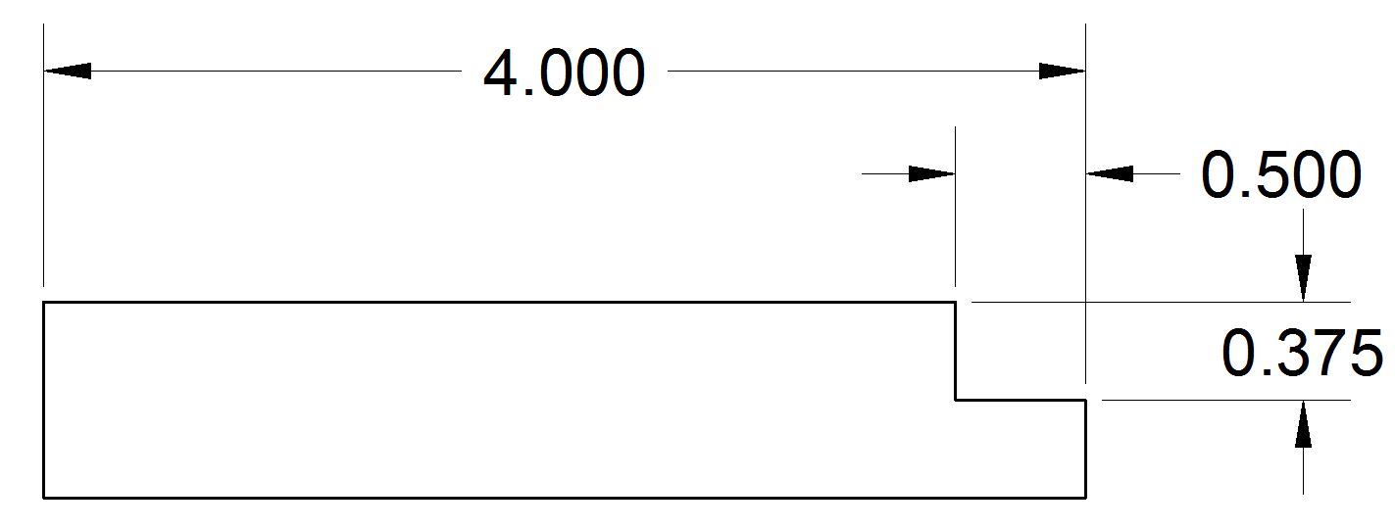

This completes Ex. 2.4A. Submit your piece to your instructor for review. Keep the finished piece as you will be doing more operations on it in your next class.

TABLE SAW SKILL EXERCISE 2.3A

Grading Criteria:

1 | Overall width (Ripping) | Overall length (Crosscut) | Accuracy of Rabbet (3/8" x 1/2") | Dimensional Accuracy +/- 1/32"
2 | Quality | Quality | Quality | Quality = minimal burning or tearout

Total: ______/6 pts

Comments:

