Exercise 11.1

PORTABLE ROUTER

Completed | Procedure
□ | 1. Review the router Safety Rules.
□ | 2. Obtain a piece of stock 3/4" x 9" x 9" from the instructor.
□ | 3. Install a 3/8” Rabbet bit in the router, and set it for 3/16" depth. Clamp the stock in place using a vise and bench stop, and rout 3/8" x 3/16" rabbets on the 2 edges, as shown. Remove the bit when complete.
□ | 4. Install a ¾” straight bit in the router and install the Microfence Edge guide. Adjust the Edge guide to cut the 3/4" dado you have laid out. With the piece held firmly by the vise, rout a 3/16” deep dado.
□  □ | 5. Obtain a Plunge router and install a ½” straight or spiral-up bit. Layout the free-hand recess to the dimensions shown in the drawing. Set the plunge stop so the bit will cut 3/16” deep. Make sure the piece is firmly clamped, and keep a firm grip on the router. You will be routing freehand. Try to cut as close to the line as you can, without going over.  6. Install a 5/8” Template Guide on the router (note you may need to replace the sub-base). Using the template for this exercise, rout a second recess 3/16” deep as shown in the drawing. Use double stick tape or clamps to secure the template in place. You will find it is much easier to control the router with the template and template guide.
□ | 7. Using a fixed-base router, install a 1/4" radius bearing guided round-over bit in the collet. Set the depth so that the bit will round the edge, but not leave a ridge, as shown in the diagram. Use the router to round over the 2 edges on the same face but opposite the edges with the rabbets.
□  □ | 8. Using a plunge router, install a 3/8" round nose ("Core box) bit. Also install the edge guide with circular routing attachment. Set the depth at 3/16".  9. On the back side of the stock, mark the center and drill a 5/32” hole, 1/2" deep.  Use the drill press to ensure a straight hole.
□ | 10. Obtain the correct wooden sub-base for this operation to prevent the router from tipping. The sub-base can simply be double-stick taped in place. Set the circular routing attachment for a 4" radius to the center of the bit.
□ | 11. Clamp the work-piece firmly with the vise and bench stop or vacuum jig, and rout a 3/16” deep circle on the back of the piece.
□ | 12. Unplug the router. Remove the bit and attachments, and immediately put them away. You have now completed the portable router exercise.

PORTABLE ROUTER EXERCISE

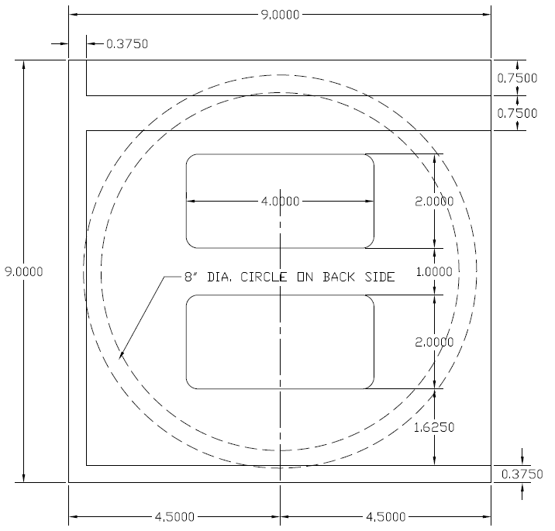

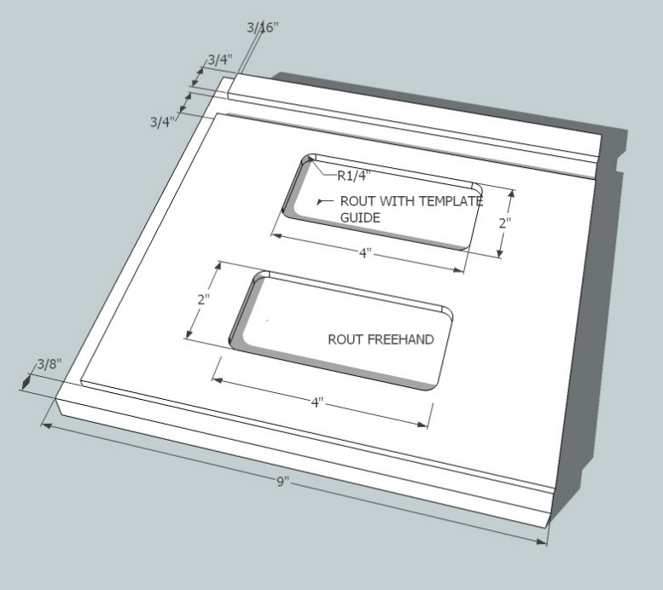
Note: Measure 4” to the centerline of the bit for the 8” circle.

Scoring Guide:
Accuracy of Rabbet  3/8" x 3/16" | Accuracy of Dado (width/depth)  3/4" x 3/16" | Accuracy of Freehand (+/-) 1/16"; Accuracy with jig 1/64" | Shaped Edge (Consistent, tangent & correct radius) | Accuracy of Circle (8" to C.L. of bit; depth of cove) | Dimensional Accuracy +/- 1/32" U.N.O.; Quality = no Tearout or Burning
Quality | Quality | Quality | Quality | Quality

Total: ______/10 (min. score: 8/10)

Comments:

