Ex. 6.1 - Fixed Spindle Shaper Instructions

(A copy of these instructions is in the Shaper Handbook in the lab)

COMPLETED | PROCEDURE
□  □  □ | - Review the Shaper Safety Rules.  - Working with a partner, obtain or mill the stock to specifications, as shown in the drawing (11/16”x3”x12”) If you are working in pairs, you will each need a final piece to submit, plus a test piece for setup. NOTE: All pieces must be the same thickness.  3. With the machine locked out, install a ½” dia. Bead cutter with a 2.3125″ (2-5/16”) diameter ball-bearing collar on the spindle, with washers, above and below the bearing (Use the drawing in the setup manual). Install the fence with aluminum faces in line, so that the “tip” of the bead is aligned with the surface of the fence, as shown in the diagram. (This can be difficult to achieve. See final page of these instructions for an alternative approach.) The fence should be approximately parallel to the front edge of the machine.  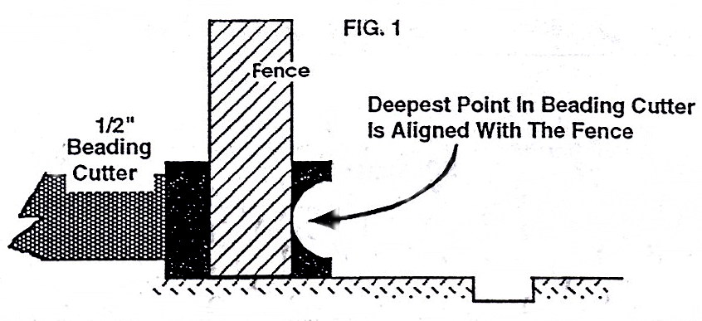
□ | 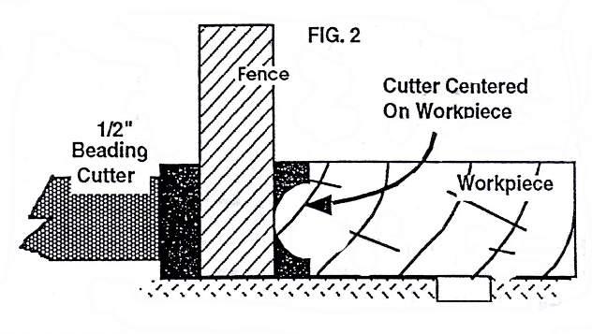  4. Adjust the fence opening to the minimum necessary. Use one piece as a gauge, and adjust the cutter height until the bead is centered on the edge, as shown in the diagram.

COMPLETED | PROCEDURE
□  □  □  □ | 5. Clear off the table, be sure fence is bolted down, and you have dust collection. Have your instructor inspect your setup and remove the lockout device.  6. You are now ready to cut. Switch the shaper ON. Keeping your hands well clear of the cutter, as shown in the demonstration, shape the leading 2” of one edge of your test piece. Switch the shaper OFF.  7. Check the cut to make sure it is centered. If not, adjust the cutter height and shape an additional 2” of the edge. Repeat until the cutter is centered, then shape the full length of one edge of your test piece using the Aigner small parts holder. NOTE: You may need to joint the shaped edge to re-straighten it for additional trial cuts. (It is not necessary to completely remove the bead. Just joint enough to create a straight, flat edge).  8. Check the test piece for any snipe or taper. If necessary, readjust the fence halves, or the depth of the cut. Make test cuts until the bead is produced without snipe or taper. NOTE: before each test cut, joint the edge of the test piece lightly, to create a straight edge. A jointer cut of only 1/16” should be sufficient.
□  □  □ | Final Cut (bead)  9. When the cutter height is truly centered and the cut is true, shape one edge of your final piece.  Set-up (curved bead)  10. Lock out the shaper and back the fence away. NOTE: The fence is not needed for this operation.  11. Obtain the jig for Exercise 8.4. Clamp your test piece in the jig as shown in the diagram, and raise the spindle until the cutter is centered on the shaped bead.  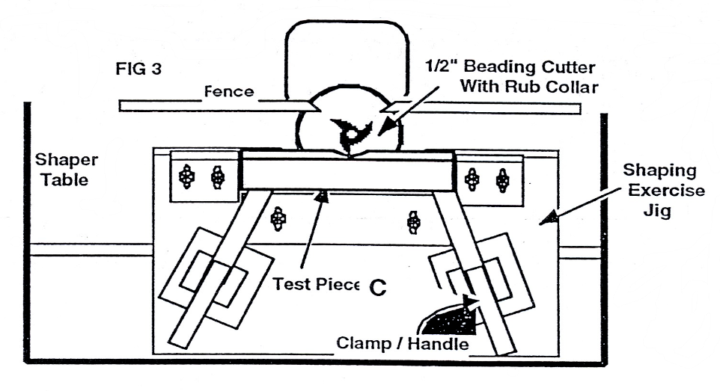

COMPLETED | PROCEDURE
□  □ | 12. Remove the test piece from the fixture. Using the sample provided, layout the curve along the beaded edges of “A” and “C”, and band saw to within 1/16″ of the line, as shown on the drawing. DO NOT ATTEMPT TO SHAPE THE MATERIAL WITHOUT REMOVING IT BEFOREHAND WITH THE BANDSAW!  13. Ask your instructor to inspect the setup. Return your test piece to the fixture and shape the sawn contour. Because you will typically get tearout as the cutter exits the stock, it is recommended that you shape from the left end to the middle of the stock. Pull your jig away from the cutter and flip your piece over. Cut the remaining portion of your piece in the same manner. This practice of cutting “downhill” is a good technique to help avoid tearout on curved work.  CAUTION: Always move the work piece against the rotation of the cutter.  Check with the instructor if you have any questions.  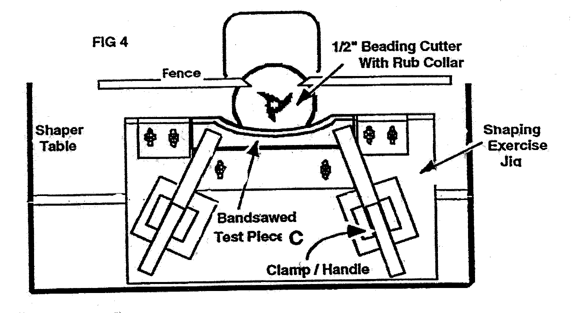
□ | Final Cut (Curved Bead)  14. Repeat this procedure with your final piece. Switch the shaper off.

COMPLETED | PROCEDURE
□  □ | Set-up (Cove)  15. Lock out the machine and remove the cutter and collar. Install a ½” fluting cutter. (Return the fence to its normal position).  16. Place the sliding shaper jig on the table, and clamp your test piece against the miter gauge as shown in Fig. 6.
□ | 17. Adjust the spindle height so that the fluting cutter is centered on your test piece, using the shaped bead as a guide.
□ | 18. Adjust the fence so that the cutter will cut approximately 1/4″ deep.

COMPLETED | PROCEDURE
□ | 19. Ask your instructor to inspect your setup. If approved, your instructor will unlock the machine. With your test piece clamped in place, feed it through the cutter slowly, cutting a cove across the end. Switch OFF. Check the centered position of the cut. Adjust if needed and repeat. NOTE: If you are getting tearout, the sacrificial backer may need to be replaced.
□ | Final Cut (cove)  20. When your set-up is correct, cut flutes in both ends of your final piece; these are referred to as “Cove #1” and “Cove #2” in the evaluation rubric.
□ | 21. Lock out the machine. Remove the cutter and guard from the spindle. Replace the fence on the table. Put all tools away. Use compressed air to blow off the shaper, and the floor around it.

You have now completed the Exercise.

Evaluation:
Put your name on your exercise piece and hand it in for review.

Alternative process for aligning fences tangent to a beading cutter:

Top Dead Center of Bead Tangent to Fence
Ideal: Fence is tangent to bead. This is difficult to do with a straightedge. So we recommend the following process….
Step 1: Slide the infeed and outfeed fences about 1/16” behind the TDC of the cutter (see photo right)
Step 2: Run a board about 2” past the cutter, then stop the machine.
Step 3: Adjust the outfeed until it just touches the stock.
Step 4: Using a straightedge, align the infeed fence with the outfeed fence.

