Ex. 6.1 - Fixed Spindle Shaper Drawing & Evaluation

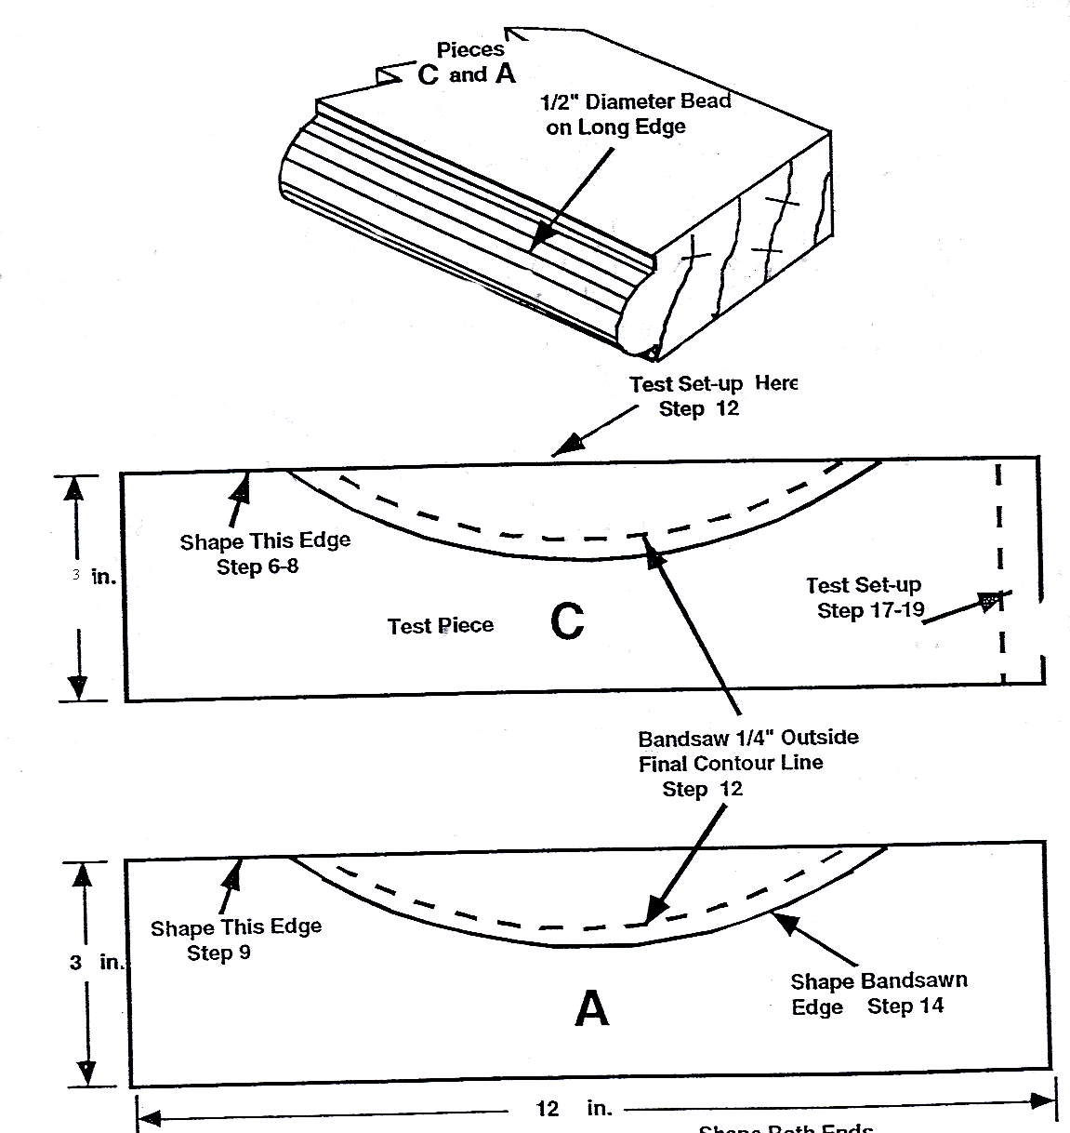

Scoring Guide:
Straight Bead is centered on stock | Curved Bead is centered on stock and blends with straight bead | Cove #1 is centered on the stock | Cove #2 is centered on the stock | Accuracy of Part dimensions
Quality of straight bead | Quality of curved bead; No overcut from band saw | Quality of Cove #1 | Quality of Cove #2 | All operations complete on 1 piece
Dimensional Accuracy +/- 1/64" Quality = no tearout or burning

Minimum passing score: 8/10 Total Points ____________
Comments: Name ___________________ Date ________

