Teaching Notes - Jointer
Time Needed 1:15 (Do checklist as part of demo)
Jointer Checklist Demo Video (16:27)

- Classroom: Purpose of the machine: What does a jointer do?
  - Make faces flat
  - Make edges flat
  - Make edge-face square
  - Video: Watch first 1-2” of Tuning a Jointer

- Lab: Review Parts & Adjustments
  - On/Off/Disconnect
  - Guard
  - Cutter head, Knives
    - Height of knives must be = (use wood block to Demo ¼” of movement
  - Infeed/Outfeed
  - Essential that they be in the same plane
    - Adjusting
    - Too High = Taper
    - Too Low = Snipe
  - Setting the outfeed
  - Fence
    - Demo Tilt, Squaring, Front to back motion
  - Rabbeting Table

- Operations:
  - Face jointing
    - Grain orientation
    - Set depth of cut
    - Using Push Blocks
    - Dealing with twist
    - Thin stock! (must be >3/8”)
  - Edge jointing
  - Grain orientation
  - Hand Pressure
  - Speed
  - Tearout
  - Marking adjacent faces

- Oliver – review parts; demo Suvamatic
- Additional Operations
  - Bevel/Chamfer
  - Tilt fence Forward/Backward (Advantages/Disadvantages)
  - Use a bevel for accuracy

  - Rabbeting
    - Remove guard
    - Set depth of cut
    - Adjust Fence
    - Pre-kerf stock?
  - Tapering
    - Partial
    - Full - 2 step (Steven’s method)
- Misc
  - Safety-Proper finger placement
  - Stance – esp. long lengths
  - Min Length (12” – 4/12 rule; 16” preferred)
  - End Grain & Relishing
  - Plywood
  - Watch out for knots and fasteners!
  - Leave machine guarded and set for 1/32” when finished

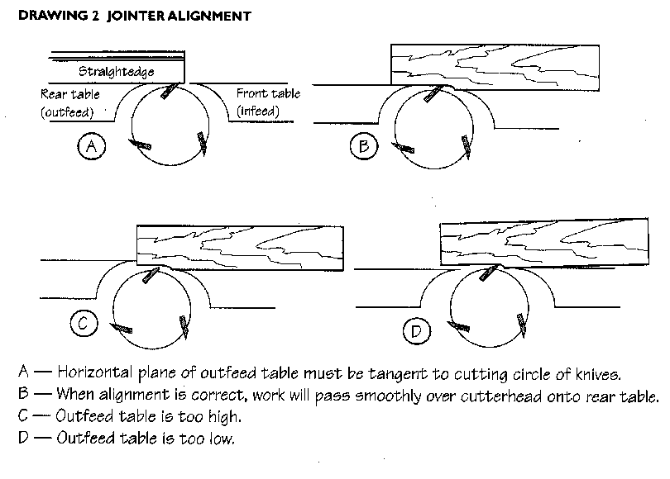

- Review Checklist for understanding
- Review Exercise criteria

