Skill Activity 2

JOINTER TABLE ALIGNMENT PROCEDURE

Completed | Procedure
- Move the fence as far back as it will go. Unplug the machine or turn off the circuit disconnect. Verify there is no power to the machine by turning it on to test.
- Loosen the table locks, and move both tables down about 1/8”. Do this only on the Ironwood Jointer.
- Turn the cutter-head so that it is in the position shown in Fig. 1
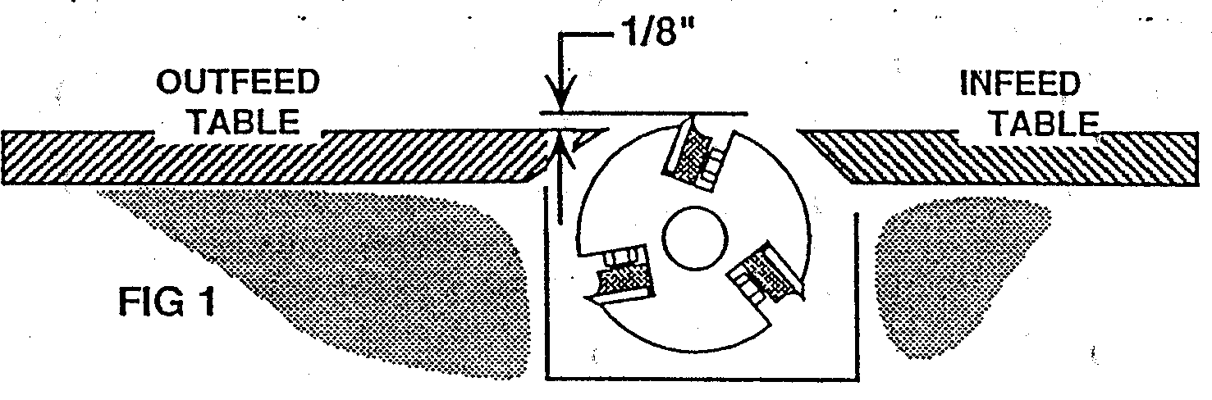

Checking the Knife Projection
For the jointer to work properly, the tips of the knives must project equally from the cutter-head. The next procedure is a method of checking that condition.
- Using a straight piece of hardwood about 12” long as a gauge, raise the out-feed table until the tips of the knives are just even with the surface of the out-feed table.
Rotating the head by hand, and with light pressure on the straightedge, each knife should touch the wood just enough to pull it approximately ¼”. Place some marks on the straightedge, as shown in Fig. 2, to help you judge the correct setting.
CAUTION: If the 3 knives do not project the same amount from the cutter-head, have the instructor check the machine.
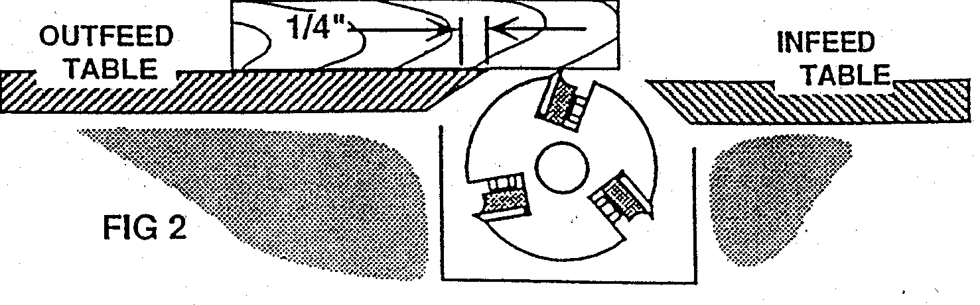

Completed | Procedure
5. When you have determined that the knives project equally from the cutter-head, you must prepare to exactly align the out-feed table even with
the cutting circle of the knives.
Replace the guard. Move the fence forward about 2″. Check it for square ness with the out-feed table. Set the in feed table to take a 1/16″ cut. Switch on the circuit disconnect.

Adjusting the Outfeed Table

The out-feed table must be set exactly tangent to the cutting circle of the knives. If the out-feed table is too high, a taper will result; if it is too low, a snipe will be cut (Modern Cabinetmaking p.436). The most accurate way to set the out-feed table is to adjust it to the actual cut made by the knives.

6. Turn on the jointer. Using a straight edged piece of stock about 12″ long, feed the stock across the knives about 3 inches, and stop. Hold the test piece in place and turn off the motor. Holding the test piece firmly onto the in feed table, raise the out-feed table until it just touches the cut surface of the stock. Lock the out-feed table

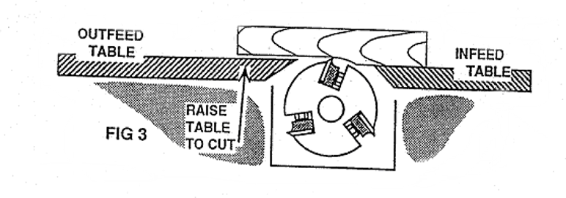

7. Joint one edge of the test board, removing about 1/16 of an inch. Check the piece for any of the defects and correct the setting if necessary.

NOTE: 2 or 3 passes may be required to determine if a taper is being cut; A snipe is sometimes caused by too much pressure when feeding, even if the jointer is correctly aligned.

