Information Sheet 2

Grain direction Diagram

When joining the EDGE of the stock,
check the grain direction of the
SIDE of the work piece.
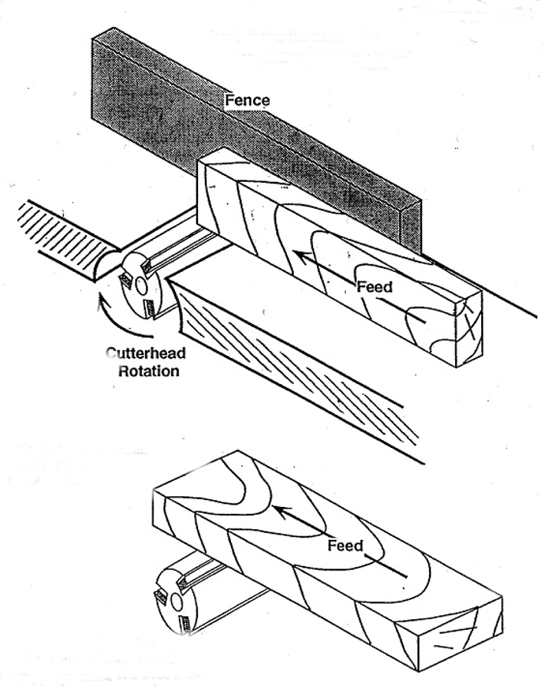

When jointing the SIDE of the stock,
check the grain direction on
the EDGE of the work piece.

NOTE: When the cutter head is below the stock, as on the jointer, the knives will
exit the stock toward your feet. The wood grain should be oriented in the same general direction

