Exercise 3.1

USING A JOINTER

Completed | Procedure
Face/Edge Jointing (Pieces 1 & 2) Material: 4/4 rough x 4” +/- x 15” +/-

- Review the Jointer Safety Rules. Madison College students: use the Ironwood jointer for this exercise.

2. Obtain the following rough sawn stock: 2 pieces of 4/4x4”x15”(Since this stock is rough sawn, dimensions are approximate)

3. Make sure the fence is square with the out-feed table. Set the jointer for a 1/32” - 1/16″ cut.

4. Switch the motor on. Joint one face on each board flat and smooth, in the right direction as indicated by the grain. Mark this face. More than one pass may be required.
NOTE: If the piece is twisted, be sure to follow the method shown by the instructor to remove the twist.
5. Hold the jointed side against the fence and joint one long edge square with that surface. Very little downward pressure is needed, but the stock must be held tightly to the fence. Check your work with your square. Switch the motor off. Take the pieces to the table saw and rip them to 3-17/32”. Return to the jointer and clean up to saw marks by removing 1/32” of material on each edge.
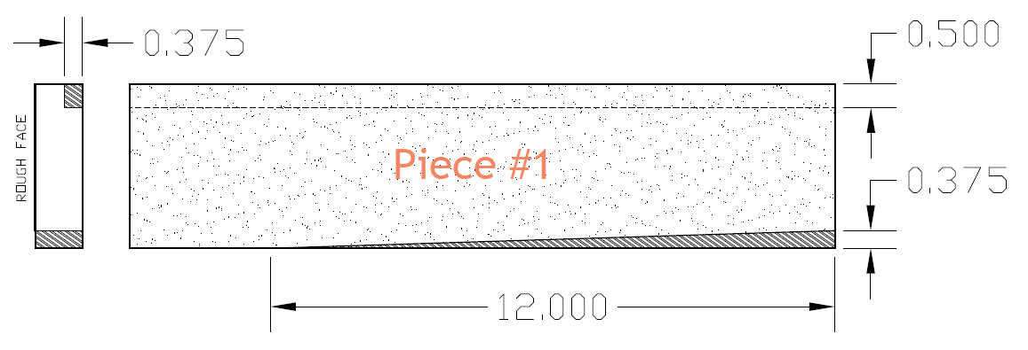
Cutting a Taper (Piece #1).
6. Move the guard back to expose a maximum of about 1″ of the knives. Orient your stock so the jointed face is towards the fence. Mark the stock 12” from the trailing end. With the machine locked out, rotate the cuter to align your mark where the cutter enters the stock. Clamp a stop block at the trailing end of your stock to prevent kickback. With the depth of cut set to 3/8” and the jointer running, lower the stock into the head with your pencil mark lining up with the leading edge of the out feed table. Hold on to the stock securely, as there is a tendency for it to want to kick back. Push the stock through to create the taper.

Cutting a Rabbet (Piece #1, continued).
Note: The workpiece will need to be pre-grooved on the Table Saw before continuing IF your jointer does not have spur cutters. (Refer to Modern Cabinetmaking Fig. 25-14).
7. Switch the motor on. Check the grain direction and cut a rabbet on one edge of the stock. Switch the motor off and replace the guard.
8. Lock out the jointer. Remove the guard. Move the fence to the left so that only 1/2″ of the ends of the knives are exposed. (Check each knife, as one may project slightly farther than the others.) Set the in feed table for a 3/8″ cut. Reconnect power. USE CAUTION! There is no guard in place for the Rabbeting Operation.

Cutting Bevels & Chamfers (Piece #2):
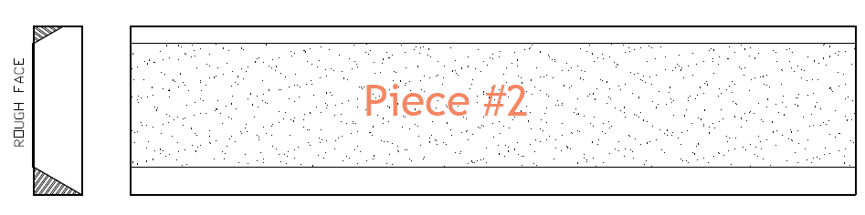
9. Tilt the fence to 30° and lock. Set the machine to cut 1/8″.
10. Switch the motor on. With the jointed face towards the fence, feed the stock carefully, chamfering 1 edge of the stock. Make 2 passes to increase the width of the chamfer.

11. Repeat this operation on the opposite edge, making as many passes as necessary until you have a bevel. Switch the motor off.

12. Return the fence to 0° (90° to the out-feed table).

Scoring Guide: √ = Criteria met
O = Criteria not met

Piece #1: |  |  | Piece #2:
Face to edge squareness | Accuracy of taper (3/8") | Accuracy of Rabbet  (1/2 x 3/8) | Angle of Chamfer  +/-.5 deg |  | Angle of Bevel  +/-.5 deg | *Dimensional Accuracy +/- 1/32"
Quality | Quality | Quality | Quality |  | Quality | Quality = minimal tearout or burning

Total: ______/10 (min score 8/10)

Comments:

